Installation Guide – GCU Rev 1

# Wiring Pinout - Module

1. Ground
2. Temp Sense
3. Temp Ref
4. -
5. Lamp B*
6. Lamp A
7. Glow Plug Relay
8. +12V

*not used on NH – NK Pajero

# Wiring Pinout – Vehicle (1995 NJ Pajero GLS)

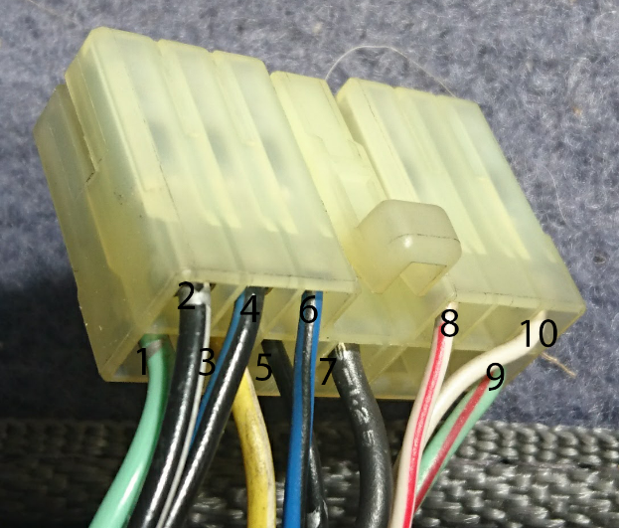

1. Glow Plug Relay Green
2. +12V Black, White Stripe
3. –
4. –
5. –
6. Lamp A Blue, Black Stripe
7. Ground Black
8. –
9. –
10. –

# Configuration

* To enter the menu, press and hold (**long press**) the button until a **long beep** is heard.
* After a moment, the unit will begin beeping with the number of beeps corresponding to different settings in the menu.
* Once the number of beeps reaches the setting you wish to configure, press briefly (**short press)** the button.
* The unit will continue beeping with the number of beeps corresponding to the options available for the setting you wish to configure.
* Once the number of beeps reaches the option you wish to apply for that setting, **short press** the button to save it permanently and exit the menu.
* The table below explains the options and the number of beeps which apply to them:

|  |  |  |  |
| --- | --- | --- | --- |
| 1 | Pre-Glow Duration |  | (seconds) |
|  | Controls how long before the dash light | 1 | 4 |
|  | goes out after turning the glow plugs on. | 2 | 6 (default) |
|  | (how long until the glow plugs are up to | 3 | 8 |
|  | temp) | 4 | 10 |
|  |  | 5 | 12 |
| 2 | Glow Duration |  | (seconds) |
|  | Controls how long before the glow plugs | 1 | 6 |
|  | should stay on after the lamp has gone | 2 | 10 |
|  | out and the engine has been started | 3 | 15 (default) |
|  |  | 4 | 20 |
|  |  | 5 | 25 |
|  |  | 6 | 30 |
|  |  | 7 | 40 |
|  |  | 8 | 60 |
|  |  | 9 | 120 |
| 3 | After-Glow Duration |  | (seconds) |
|  | Once the engine is started, the glow plugs | 1 | Disabled |
|  | toggle on/off to keep the glow plugs | 2 | 180 |
|  | warm but not so hot as to damage the | 3 | 240 (default) |
|  | glow plugs. Aids starting in very cold | 4 | 300 |
|  | weather while the engine gets up to | 5 | 360 |
|  | temperature. | 6 | 480 |
|  |  | 7 | 600 |
| 4 | After-Glow Interval |  | (seconds) |
|  | How long on, how long off. Applies to | 1 | 1 |
|  | The after-glow mode. 2 seconds is normal | 2 | 2 (default) |
|  |  | 3 | 3 |
| 5 | Glow Temp Threshold |  | (deg C) |
|  | The engine block temperature above | 1 | Disabled |
|  | which the glow plugs will not be activated | 2 | 50 |
|  | at all | 3 | 55 |
|  |  | 4 | 60 |
|  |  | 5 | 65 (default) |
|  |  | 6 | 70 |
|  |  | 7 | 75 |
|  |  | 8 | 80 |
| 6 | Temp Alert Threshold |  | (deg C) |
|  | A subtle high-temperature alert | 1 | Disabled |
|  |  | 2 | 95 |
|  |  | 3 | 98 |
|  |  | 4 | 100 (default) |
|  |  | 5 | 105 |
|  |  | 6 | 110 |
|  |  | 7 | 115 |
|  |  | 8 | 120 |
|  |  | 9 | 125 |
|  |  | 10 | 130 |
| 7 | Temp Critical Threshold |  | (deg C) |
|  | A less-subtle temperature alert | 1 | Disabled |
|  |  | 2 | 95 |
|  |  | 3 | 100 |
|  |  | 4 | 105 |
|  |  | 5 | 110 (default) |
|  |  | 6 | 115 |
|  |  | 7 | 120 |
|  |  | 8 | 125 |
|  |  | 9 | 130 |
|  |  | 10 | 135 |
| 8 | Voltage Alarm Mode |  |  |
|  | Depending on the mode, this will alert | 1 | Disabled |
|  | you to issues with the alternator or | 2 | Low Battery (<11.5V) |
|  | battery | 3 | Not Charging Only (<12.5V) |
|  |  | 4 | Over Charging Only (>15V) |
|  |  | 5 | Over Charging & Not Charging (default) |